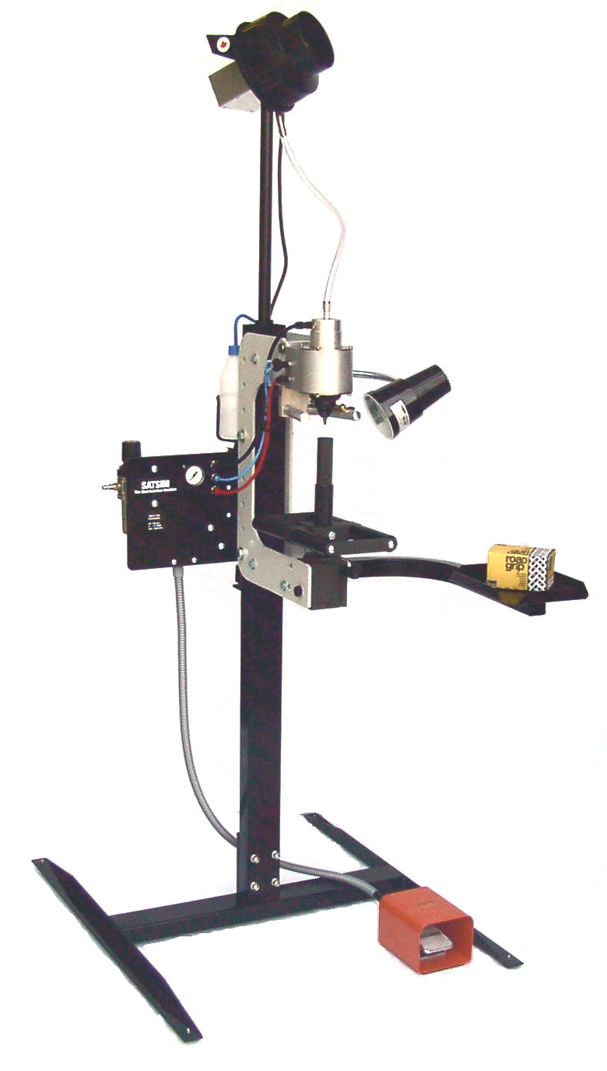
Semi Automatic Tire
Stud Insertion Machine
[Inserting Finger Style]
SATSIM

- Consistent accurate studding using “Inserting Fingers”.
- Reduces operator fatigue and increases overall studding capacity.
- Economical – affordable to even the small volume user.
- Built-In water spray jet lubrication system.
- Mounting platform allows for effortless movement in any direction of even the heaviest tires.
- Convenient adjustable working heights.
- Handy work light and swing away tool tray.

Bruno Wessel


DISTRIBUTED BY :

BRUNO WESSEL LTD.
IN CANADA
1-877-452-1935
Tel. (519) 452-1935
Fax (519) 452-3911

BRUNO WESSEL INC.

IN USA
1-800-869-1908
Tel. (914) 381-7771
Fax (914) 381-7775
www.brunowessel.com

