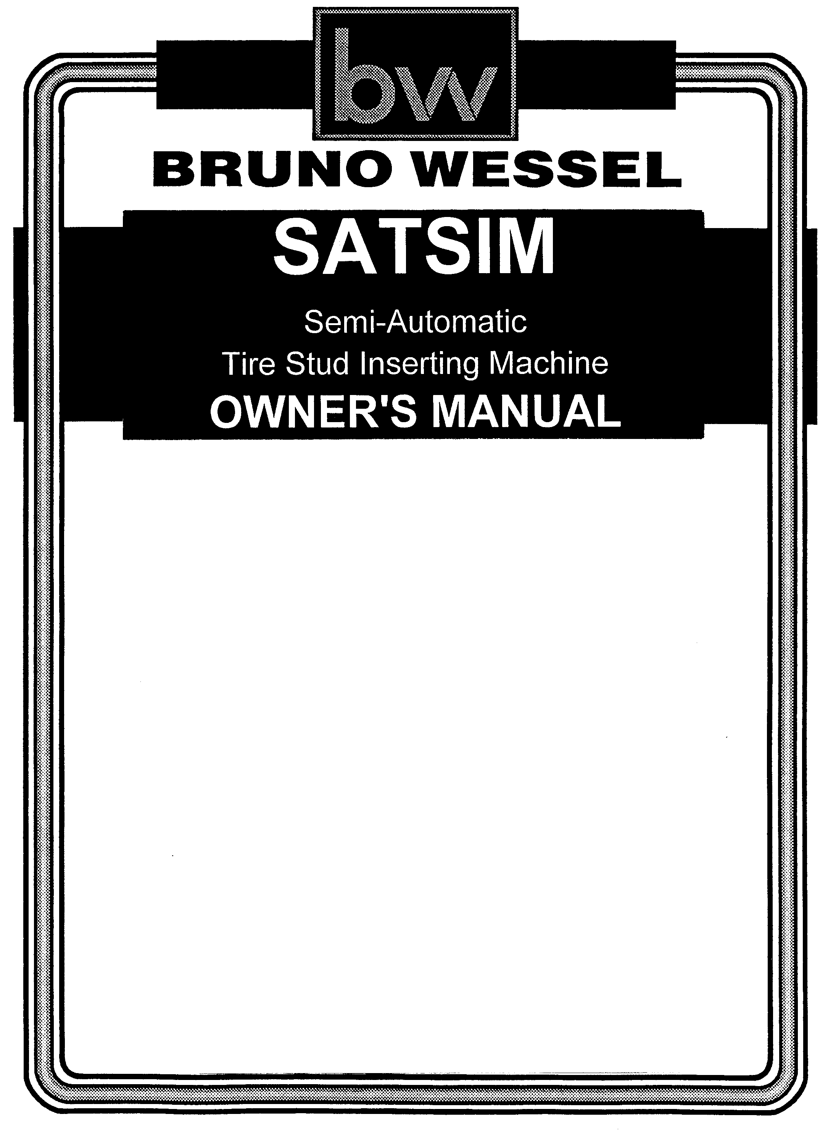
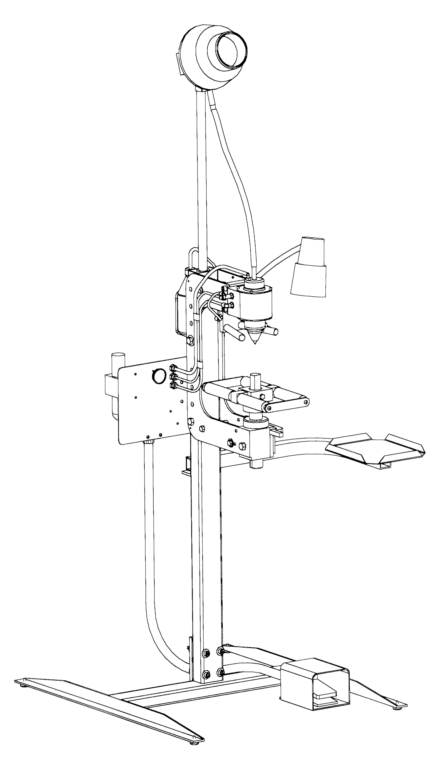

IMPORTANT SAFETY INSTRUCTIONS

Your new SATSIM comes equipped with an electric motor to operate the stud feeder.

Please read through this operating manual carefully before using your new SATSIM.
Pay close attention to all Safety Instructions. Use this machine only for it's intended
purpose.

- Read all instructions.

- Care must be taken as burns can occur from touching hot parts.

- Do not operate equipment with a damaged cord or if the equipment has been dropped or damaged - until it has been examined by a qualified serviceman.

- Do not let cord hang over edge of table, bench or counter or come in contact with hot manifolds or moving fan blades.

- If an extension cord is necessary, a cord with a current rating equal to or more than that of the equipment should be used. Cords rated for less current than the equipment may overheat. Care should be taken to arrange the cord so that it will not be tripped over or pulled.

- Always unplug equipment from electrical outlet when not in use. Never use the cord to pull the plug from the outlet. Grasp plug and pull to disconnect.

- Let the equipment cool completely before putting away. Loop cord loosely around equipment when storing.

- To reduce the risk of fire, do not operate equipment in the vicinity of open containers of flammable liquids (gasoline).

- Adequate ventilation should be provided when working on operating internal combustion engines.
- Keep hair, loose clothing, fingers, and all parts of body away from moving parts.

- To reduce risk of electric shock, do not use on wet services or expose to rain.

- Use only as described in this manual. Use only manufacturer's recommended attachments.

- ALWAYS WEAR SAFETY GLASSES. Everyday eyeglasses only have impact resistant lenses, they are NOT safety glasses.

SAVE THESE INSTRUCTIONS
SATSIM

Semi-Automatic Tire Stud Insertion Machine

Thank you for choosing a Bruno Wessel product.

Your new SATSIM is designed and built to Bruno Wessel's demanding specifications for dependability. We have earned a reputation for producing high quality, innovative and durable tire studding equipment.

Please take the time to read this owner's manual and pay particular attention to the safety and maintenance instructions.

Table of Contents Page(s)

Safety Instructions 2

Assembly Instructions 4, 5

Assembly Breakdown 6

SATSIM Maintenance 7

Operating Instructions 8, 9

Head & Spray Guide Assembly Breakdown 10, 11

Push Rod Style Assembly Breakdown 12, 13

C-Frame Assembly Breakdown 14, 15

Mandrel Assembly Breakdown 16

Pneumatic Assembly Breakdown 17

Alternate Mandrel Assembly 18

Warranty Information 19

Tools Required for Assembly

Phillips Screw Driver Socket Set SAE
Allen Key Set SAE Adjustable Wrench

SATSIM

Semi-Automatic Tire Stud Insertion Machine

ASSEMBLY INSTRUCTIONS (Refer to Figure1)

STEP “A”
- Secure Main Post (16) to SATSIM Base (18) using the four 3/8”x 3” socket head screws and nuts (17,20).

STEP “B”
- Attach C-Frame assembly (1) to main post using two 4 1/2” x ½” Hex Head Bolts w/nuts (11).
- Align holes in C-Frame with holes in the column to obtain desired working height.

STEP “C”
- Connect Roller assembly (2) to C-Frame by inserting threaded shaft into swivel block.

STEP “D”
- Attach Control Panel (22) to main post using four ¼-20 x ½” screws (12).
- Place foot pedal (21) at convenient location.

STEP “E”
- Attach work tray (14) to bracket at the back of the main post using ½” x 3” bolt, nut and washers (13,15) .

STEP “F”
- Attach water bottle holder (9) to back of main post using two 10-24 x ½” screws (10).
- Fill bottle (8) with clean water and place in holder.
- Attach clear blue tubing to the nozzle of the water bottle. Refer to Fig. 3. Page 9.

STEP “G”
- Insert feeder post (7) into hole at top of main post and tighten set screw.

STEP “H”
- Attach lamp w/magnetic base (3) to right side of C-Frame .

STEP “I”
- Connect feeder (5) w/optional motor (6) to top of feeder post
- Connect clear plastic feeder hose (4) from feeder to input tube of SATSIM as per Fig 3. Cut to proper length.

PNEUMATIC CONNECTIONS

Connect the three air lines as per Fig 2. Page 9. The “Insert” pressure fitting and tubing is 8mm and Black. The “Stroke” Pressure is Blue and the “Retract” pressure is Red.

Note: Tubing may be connected or disconnected by pushing firmly on the plastic ring of the fitting and simultaneously inserting or removing the tubing.

ASSEMBLY DIAGRAM
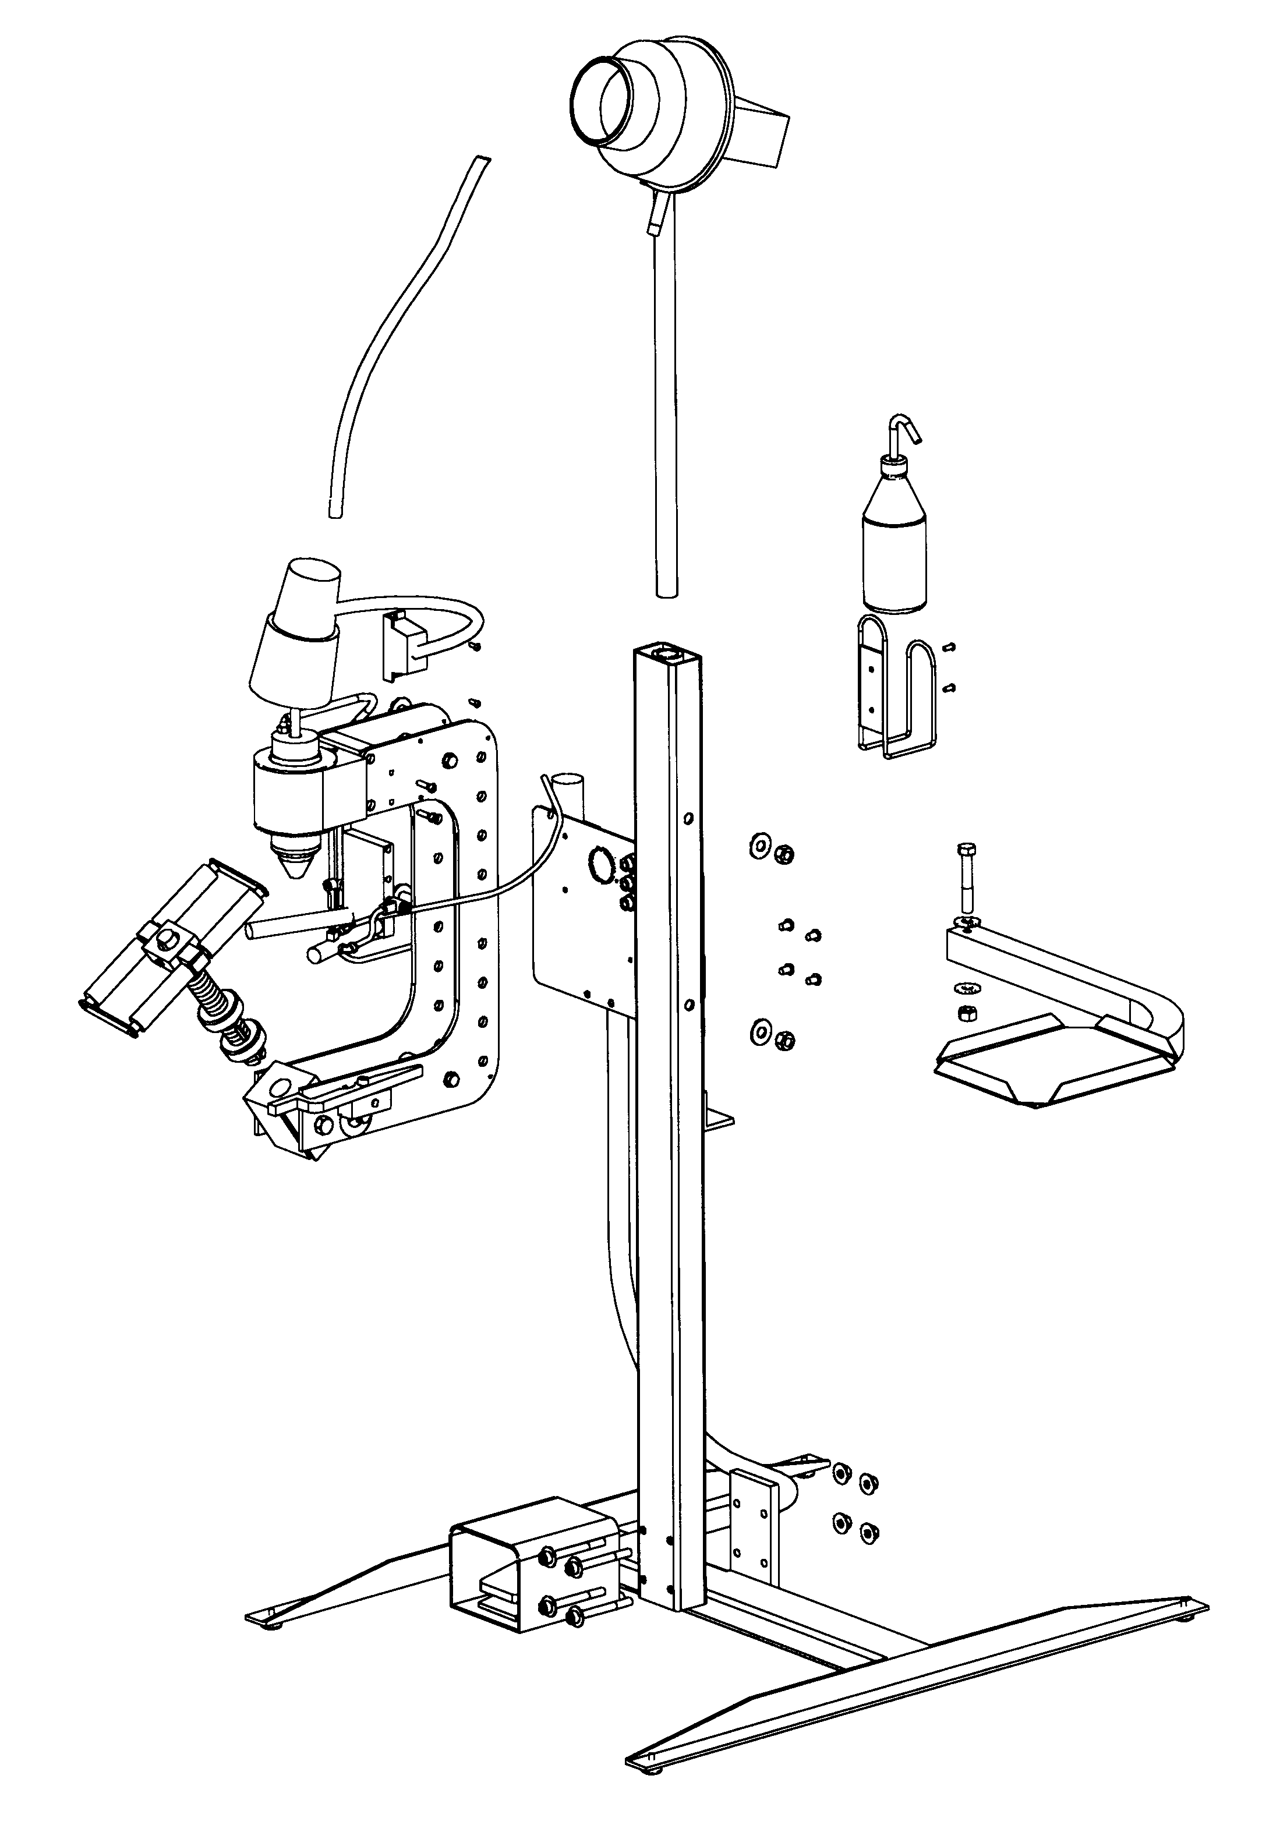
1
2
3
4
6
5
7
8
9
10
11
12
14
15
16
17
18
19
13
20
21
22
FIGURE 1

FIGURE 1 SATSIM ASSEMBLY BREAKDOWN

ITEM QUANTITY PART NUMBER DESCRIPTION

 | 1 |  | 1 |  | MFG 400101 |  | C-Frame ASSY.
 | 2 |  | 1 |  | MFG 400106 |  | Roller ASSY.
 | 3 |  | 1 |  | MFG 600112 |  | Lamp ASSY.
 | 4 |  | 1 |  | STP 0161 |  | Feed Hose 9mm
 | 5 |  | 1 |  | STE BWFP-9A |  | Feeder 9mm
 | 6 |  | 1 |  | STP 0177-110 |  | Motor
 | 7 |  | 1 |  | MFG 100146 |  | Feeder Post
 | 8 |  | 1 |  | MFG 200074 |  | Water Bottle
 | 9 |  | 1 |  | MFG 200075 |  | Bottle Holder
 | 10 |  | 2 |  | MFG 200104 |  | 10 – 24 Screws
 | 11 |  | 2 |  | MFG 200016 |  | ½ - 13 Nut
 | 12 |  | 4 |  | MFG 200015 |  | ¼ - 20 Screws
 | 13 |  | 1 |  | MFG 200106 |  | ½ - 13 x 3” HHCS
 | 14 |  | 1 |  | MFG 400026 |  | Tray ASSY.
 | 15 |  | 1 |  | MFG 200105 |  | ½ - 13 Washer
 | 16 |  | 1 |  | MFG 100005 |  | Main Post
 | 17 |  | 4 |  | MFG 200018 |  | 3/8 – 16 Nut
 | 18 |  | 1 |  | MFG 400104 |  | SATSIM Base
 | 19 |  | 4 |  | MFG 200103 |  | Floor Levelers
 | 20 |  | 4 |  | MFG 200007 |  | 3/8 – 16 x 3” SHCS
 | 21 |  | 1 |  | MFG 300152 |  | Foot Valve
 | 22 |  | 1 |  | MFG 400100 |  | Pneumatic ASSY.

SATSIM MAINTENANCE

The SATSIM has been designed to require a minimum amount of owner maintenance. The modular design allows for the quick exchange of main assemblies. It is recommended that service on internal components be performed by factory trained personnel.

1. The SATSIM requires a clean dry input air supply. Working pressure is 90 -150 psi. (600 - 1000 kPa)

2. The air filter and lubricator use polycarbonate bowls. The maximum supply pressure for these bowls is 220 psi and maximum operating pressure is 150 psi.
Regularly inspect these bowls for cracks or signs of brittleness. Polycarbonate bowls can be attacked by a wide variety of aggressive chemicals.

3. The air filter uses a manual drain system. To drain unit, remove air supply first. Drain unit by pressing button on the drain valve at the bottom of the filter. Regularly inspect for the presence of a large amount of fluid in the bowl as shown in the sight glass. If this occurs, REMOVE INPUT AIR SUPPLY, unscrew bowl, drain water and inspect filter elements for debris.

SAFETY: After any adjustment or maintenance has been carried out, ensure that all fittings and spacers are firmly attached and that all bowls are securely screwed into position,

4. Internal lubrication is provided by an oil lubricator. Recommended oil is ISO VG32. To add oil, remove input air supply, remove black screw at top of lubricator and fill bowl two-thirds full. Monitor oil supply regularly and fill when required. Adjust mist control on oiler to mid point.

5. Internal wearing items include parts common to many stud inserting tools. The majority of these parts are easily replaced by the operator. To access the internal parts, push up firmly on the tool head while unscrewing the retaining nut.

WARNING: Care should be taken when servicing this assembly as there is a strong internal spring maintaining pressure on the head.

6. If studs fail to install, check inserting fingers (part 0126) for wear or bending.

7. For service parts call your studding equipment distributor. For technical assistance, call 1-800-465-3464 in North America, or 01-519-452-1935 in Europe.
SATSIM

Semi-Automatic Tire Stud Insertion Machine

OPERATING INSTRUCTIONS

Inserting Finger Style Machine

  - Connect air supply to ¼” female fitting of regulator on control panel. The SATSIM works best with a supply of 120-150 PSI (8-10 BAR) of clean dry air.

  - Adjust regulator knob clockwise until gauge on front of control panel reads approximately 110 PSI (7.5 BAR).

  - Unlock and pivot the roller assembly to the forward position. This will allow a test of the unit and ensure the inserting fingers do not strike the anvil of the roller assembly.

  - Test unit by repeatedly stepping on the foot pedal. The head assembly should move in a downward direction and the inserting fingers should extend out of the head.

  - Step on the foot pedal and keep it pressed down. Adjust the water spray at the flow control. Loosen the lock-nut and adjust counter-clockwise for more spray. See FIG 3. Note: To start the flow of water, it may be necessary at first to prime the sprayer by squeezing the bottle and forcing a flow through the tube.

  - Release foot pedal and mount a tire onto the roller assembly. Move roller assembly forward into the locked position. Adjust the roller assembly so that the anvil is approximately 1/16” ( 1.5mm) from the rubber on the inside of the tire. The roller assembly is adjusted by raising or lowering the tire with the top elevating nut.

  - Use the bottom elevating nut to raise the tire until the external fingers are approximately 1/8” (3mm) from the tire tread.

  - Load stud feeder with the required size of studs and ensure the studs are flowing through the feed hose into the feed tube of the machine.

  - Line up the external fingers with a stud hole in the tire and operate the foot pedal. Release the foot pedal immediately after the stud is installed.

  - If the stud does not seem to be at the correct depth, adjust the main regulator on the control panel. The gauge on the front of the control panel will indicate the current operating pressure of the SATSIM. An increase in pressure will cause the studs to be inserted deeper.
WARNING: Do not adjust past 150 PSI (10 BAR)

  - Ensure the water spray is directed at the external fingers as they enter the stud hole. The direction of the spray can be adjusted by loosening the screw at the back of the spray guide.

OPERATING DIAGRAM
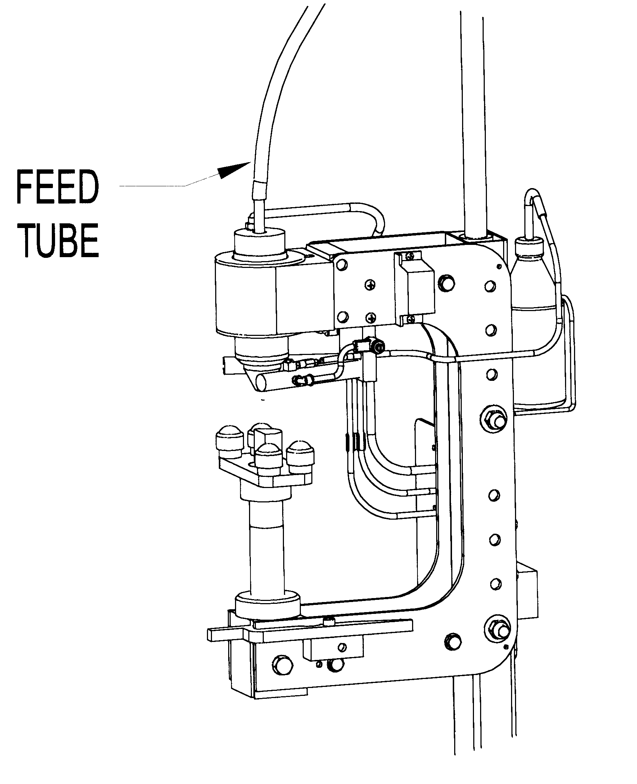
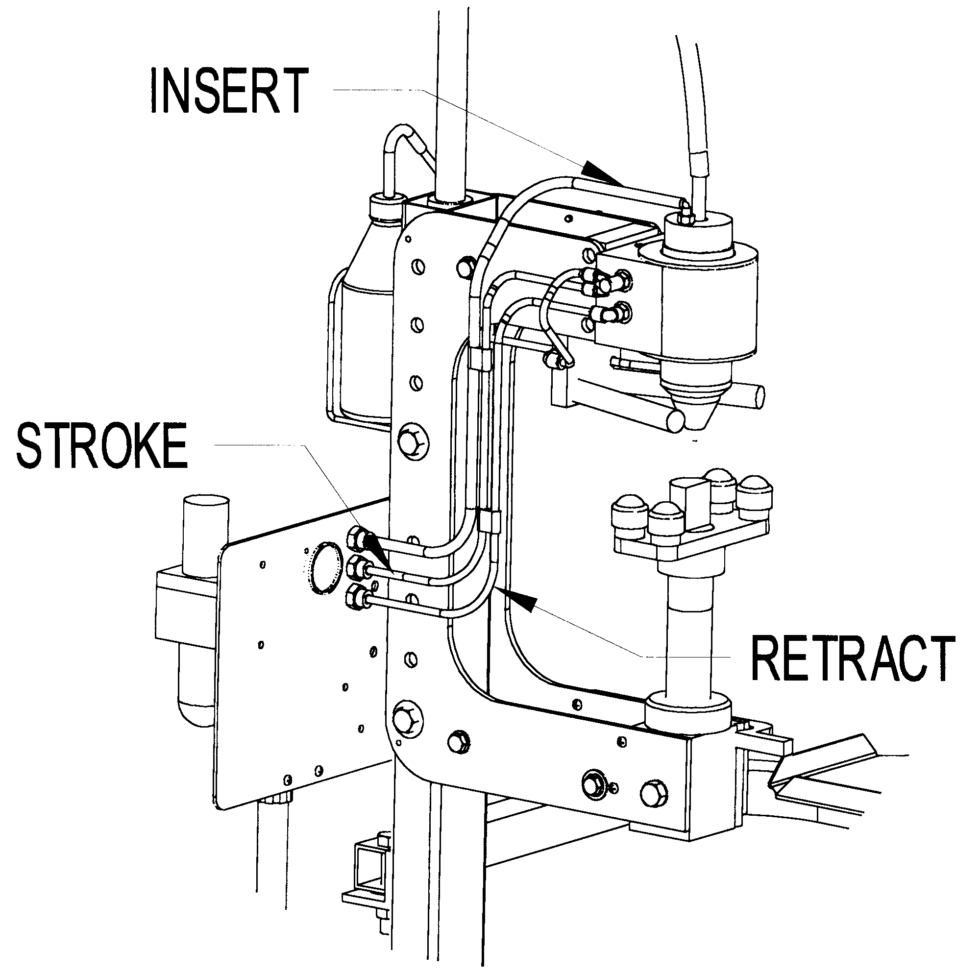
Water Spray Adjustment
(Black)
(Blue)
(Red)
FIGURE 2
FIGURE 3

FIGURE 4 HEAD & SPRAY GUIDE ASSEMBLY BREAKDOWN

ITEM QUANTITY PART NUMBER DESCRIPTION

 | 1 |  | 1 |  | MFG 100105 |  | Guide Support Plate
 | 2 |  | 2 |  | MFG 200015 |  | 1/4-20 x 1/2" Screw
 | 3 |  | 1 |  | MFG 300122 |  | Flow Control
 | 4 |  | 1 |  | MFG 300134 |  | Check Valve and Fitting
 | 5 |  | 1 |  | MFG 300120 |  | M5 x 6 Elbow
 | 6 |  | 1 |  | MFG 100101 |  | Right Guide w/Water Spray
 | 7 |  | 1 |  | MFG 100104 |  | Left Guide
 | 8 |  | 2 |  | MFG 200082 |  | 5/16 x 1" Hex Socket Cap Screw
 | 9 |  | 1 |  | STP 0136 |  | O-Ring
 | 10 |  | 1 |  | MFG 100138 |  | Feed Tube 9mm
 | 10 |  | 1 |  | MFG 100140 |  | Feed Tube 8mm
 | 11 |  | 1 |  | STP 0383 |  | Piston Cup
 | 12 |  | 1 |  | STP 0129 |  | Piston
 | 13 |  | 3 |  | STP 0126 |  | Inserting Finger
 | 14 |  | 1 |  | STP 0092 |  | Piston Cup
 | 15 |  | 1 |  | STP 0135 |  | Steel Ring
 | 16 |  | 1 |  | STP 0088 |  | O-Ring
 | 17 |  | 1 |  | STP 0131 |  | Tapered Cone
 | 18 |  | 1 |  | STP 0134 |  | Compression Spring
 | 19 |  | 1 |  | STP 0132-09 |  | Head 9mm
 | 19 |  | 1 |  | STP 0132-08 |  | Head 8mm
 | 20 |  | 3 |  | STP 0127 |  | Metering Lever
 | 21 |  | 3 |  | STP 0084 |  | External Finger
 | 22 |  | 1 |  | STP 0087 |  | O-Ring
 | 23 |  | 1 |  | STP 0133 |  | Ring Nut
 | 24 |  | 8 |  | MFG 200014 |  | 10-24 x 1/2 Socket Head Screws
 | 25 |  | 2 |  | MFG 100143 |  | Head Washer
 | 26 |  | 2 |  | MFG 200059 |  | O-Ring
 | 27 |  | 3 |  | MFG 200061 |  | O-Ring
 | 28 |  | 1 |  | MFG 100103 |  | Lower Bearing
 | 29 |  | 1 |  | MFG 102003 |  | Insertion Tool
 | 30 |  | 1 |  | MFG 300096 |  | 1/8-8 Elbow Fitting
 | 31 |  | 1 |  | MFG 102001 |  | Cylinder Housing
 | 32 |  | 1 |  | MFG 100144 |  | Upper Bearing
 | 33 |  | 1 |  | MFG 200090 |  | Wiper Seal
 | 34 |  | 2 |  | MFG 200012 |  | 3/8 x 1" Socket Head Cap Screws
 | 35 |  | 4 |  | MFG 200001 |  | 1/2 x 5/8 Socket Head Shoulder Scr
 | 36 |  | 1 |  | MFG 102002 |  | Guide Support Plate
 | 37 |  | 1 |  | MFG 300100 |  | 1/8-6 Y Fitting
 | 38 |  | 1 |  | MFG 300099 |  | 1/8-6 Elbow

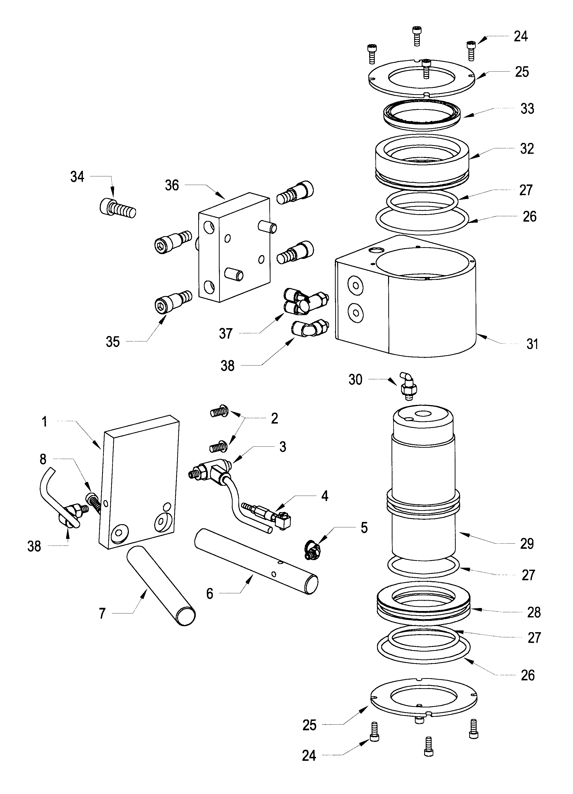
HEAD & SPRAY GUIDE ASSEMBLY
10
11
12
13
14
15
16
17
18
19
20
21
22
23
9
FIGURE 4

FIGURE 5 C-FRAME ASSEMBLY BREAKDOWN

ITEM QUANTITY PART No. DESCRIPTION

 | 1 |  | 1 |  | MFG 103000 |  | Frame LH Steel
 | 2 |  | 1 |  | MFG 102000 |  | Frame RH Steel
 | 3 |  | 3 |  | MFG 102008 |  | Spacer C-Frame
 | 4 |  | 7 |  | MFG 200019 |  | Washer 3/8"
 | 5 |  | 7 |  | MFG 200092 |  | 3/8 x 1 1/4 " HHCS
 | 6 |  | 4 |  | MFG 200024 |  | Washer 1/2"
 | 7 |  | 2 |  | MFG 200016 |  | 1/2" Nut
 | 8 |  | 1 |  | MFG 200079 |  | 3/8 x 1" Socket Head Shoulder Screw
 | 9 |  | 1 |  | MFG 200084 |  | Spring
 | 10 |  | 1 |  | MFG 100115 |  | Locking Lever
 | 11 |  | 1 |  | MFG 100114 |  | Mounting Block, Locking Lever
 | 12 |  | 4 |  | MFG 200002 |  | ¼”-20 x 1/2" Screws
 | 13 |  | 2 |  | MFG 102010 |  | Shoulder Bolts, machined
 | 14 |  | 2 |  | MFG 102013 |  | Plastic Bushings
 | 15 |  | 2 |  | MFG 100113 |  | Thrust Washers
 | 16 |  | 1 |  | MFG 100116 |  | Swivel Block
 | 17 |  | 2 |  | MFG 102009 |  | Stop Rod
 | 18 |  | 1 |  | MFG 200015 |  | 1/4-20 x 1/2 Phillips
 | 19 |  | 2 |  | MFG 200013 |  | 1/2-13 x 4 1/2" HHCS

C-FRAME ASSEMBLY
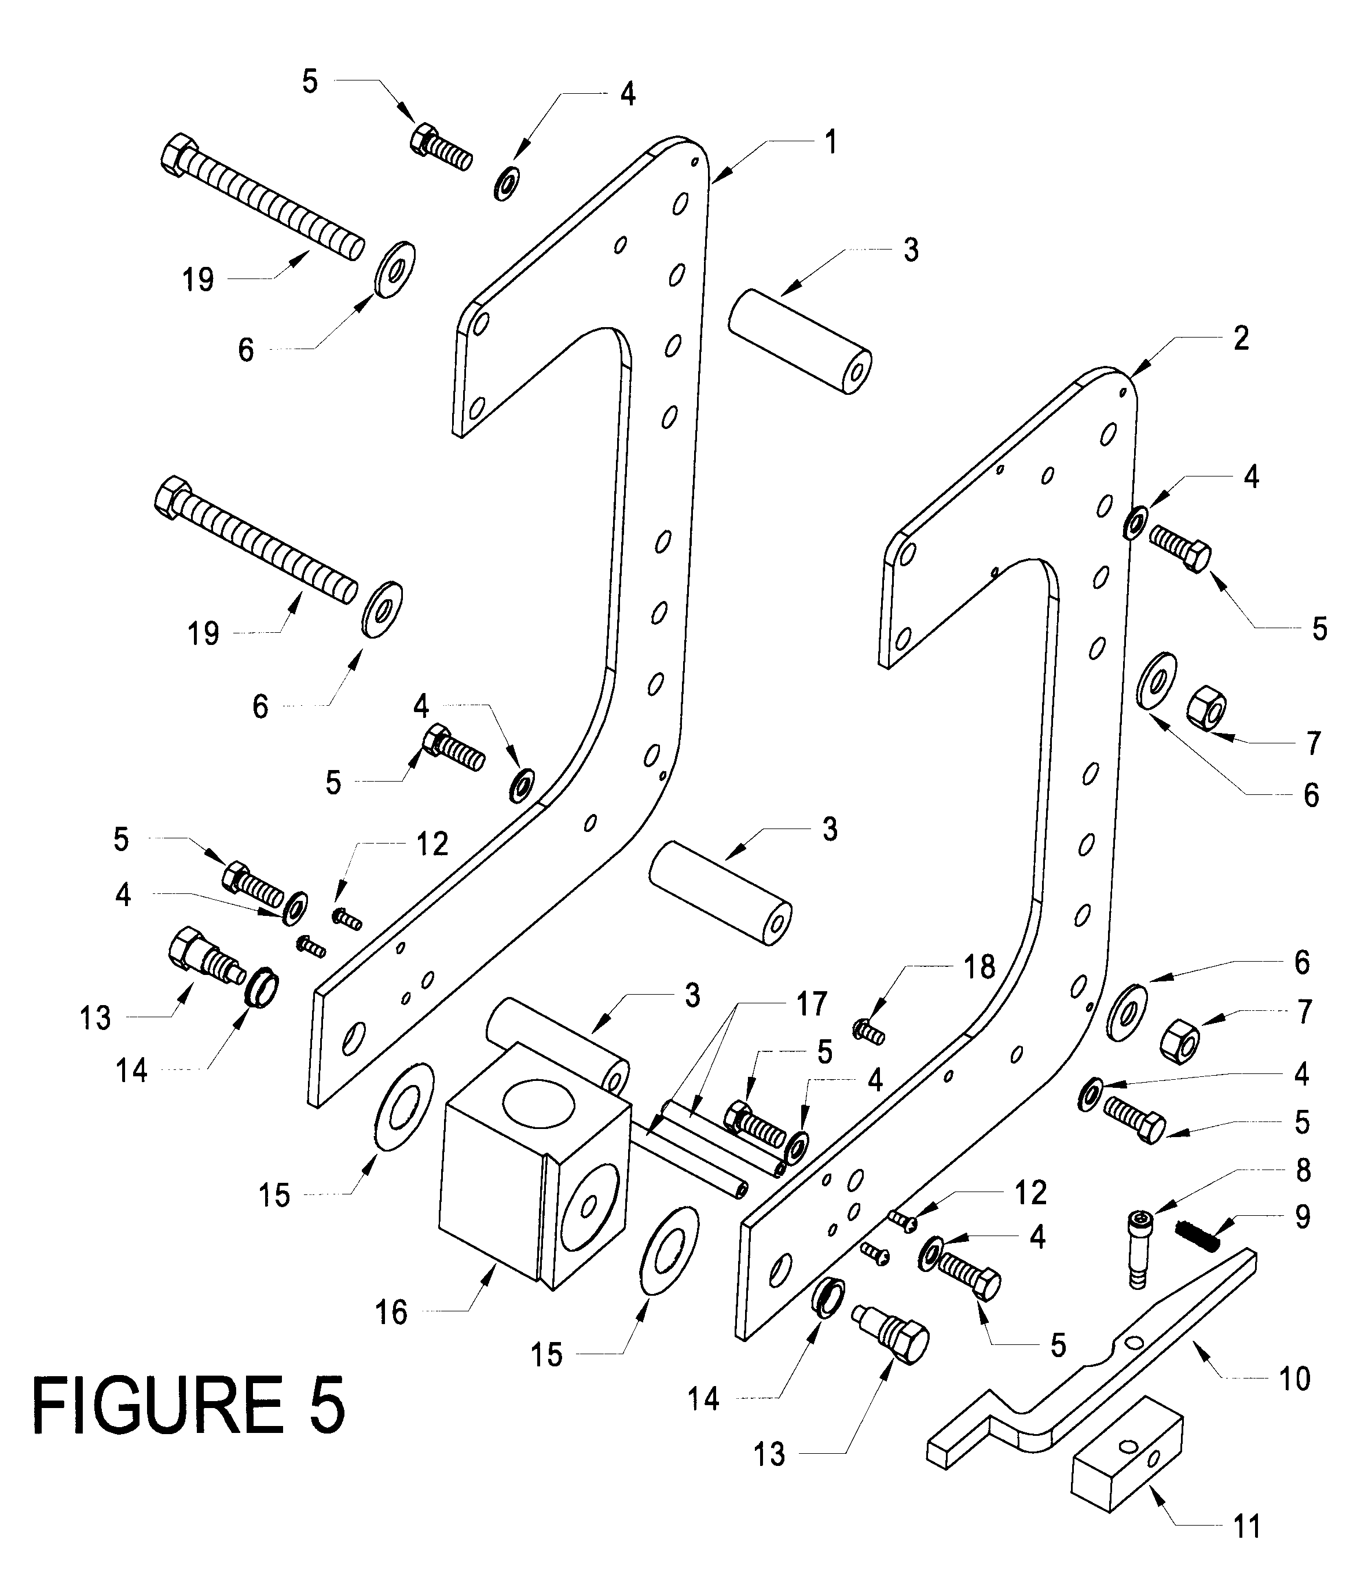
FIGURE 5

FIGURE 6 MANDREL ASSEMBLY BREAKDOWN

ITEM QUANTITY PART NUMBER DESCRIPTION
 | 1 |  | 1 |  | MFG 100118 |  | Elevating Rod Threaded
 | 2 |  | 2 |  | MFG 100131 |  | Elevating Nut
 | 3 |  | 4 |  | MFG 200015 |  | ¼-20 x ½” Screws
 | 4 |  | 2 |  | MFG 100147 |  | Bracket
 | 5 |  | 4 |  | MFG 100148 |  | Roller
 | 6 |  | 2 |  | MFG 100145 |  | Swivel Blocks
 | 7 |  | 1 |  | MFG 100146 |  | Center Block
 | 8 |  | 1 |  | MFG 100150 |  | 3/8” Machined Bolt
 | 9 |  | 2 |  | MFG 100149 |  | Rod
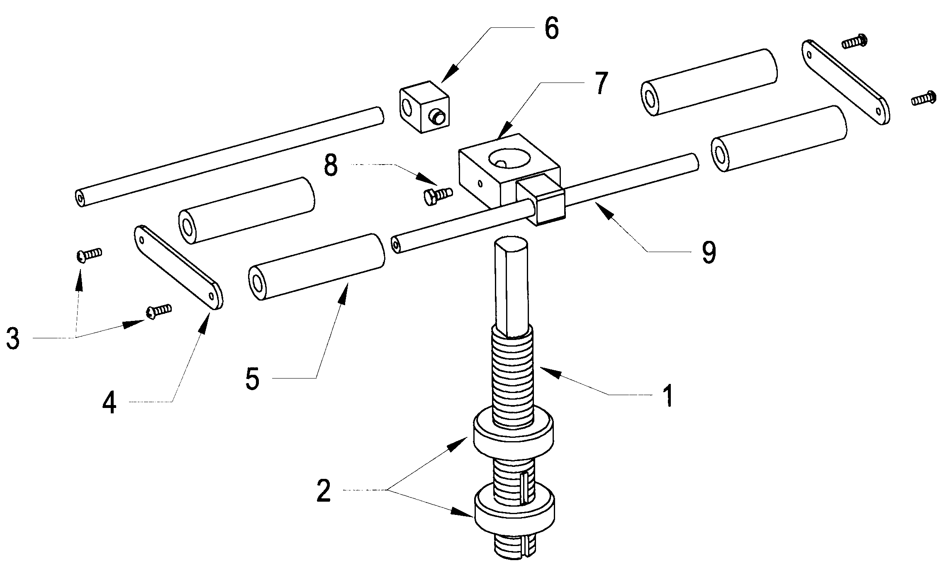
FIGURE 6

FIGURE 7 PNEUMATIC ASSEMBLY BREAKDOWN

ITEM QUANTITY PART NUMBER DESCRIPTION
 | 1 |  | 1 |  | MFG 300116 |  | Conduit Bracket
 | 2 |  | 1 |  | MFG 300113 |  | Conduit
 | 3 |  | 1 |  | MFG 300115 |  | Bracket Nut
 | 4 |  | 1 |  | MFG 300154 |  | Control Valve
 | 5 |  | 1 |  | MFG 300112 |  | Muffler
 | 6 |  | 1 |  | MFG 300111 |  | Pressure Gauge
 | 7 |  | 1 |  | MFG 300078 |  | Oiler
 | 8 |  | 1 |  | MFG 300077 |  | Filter/Regulator

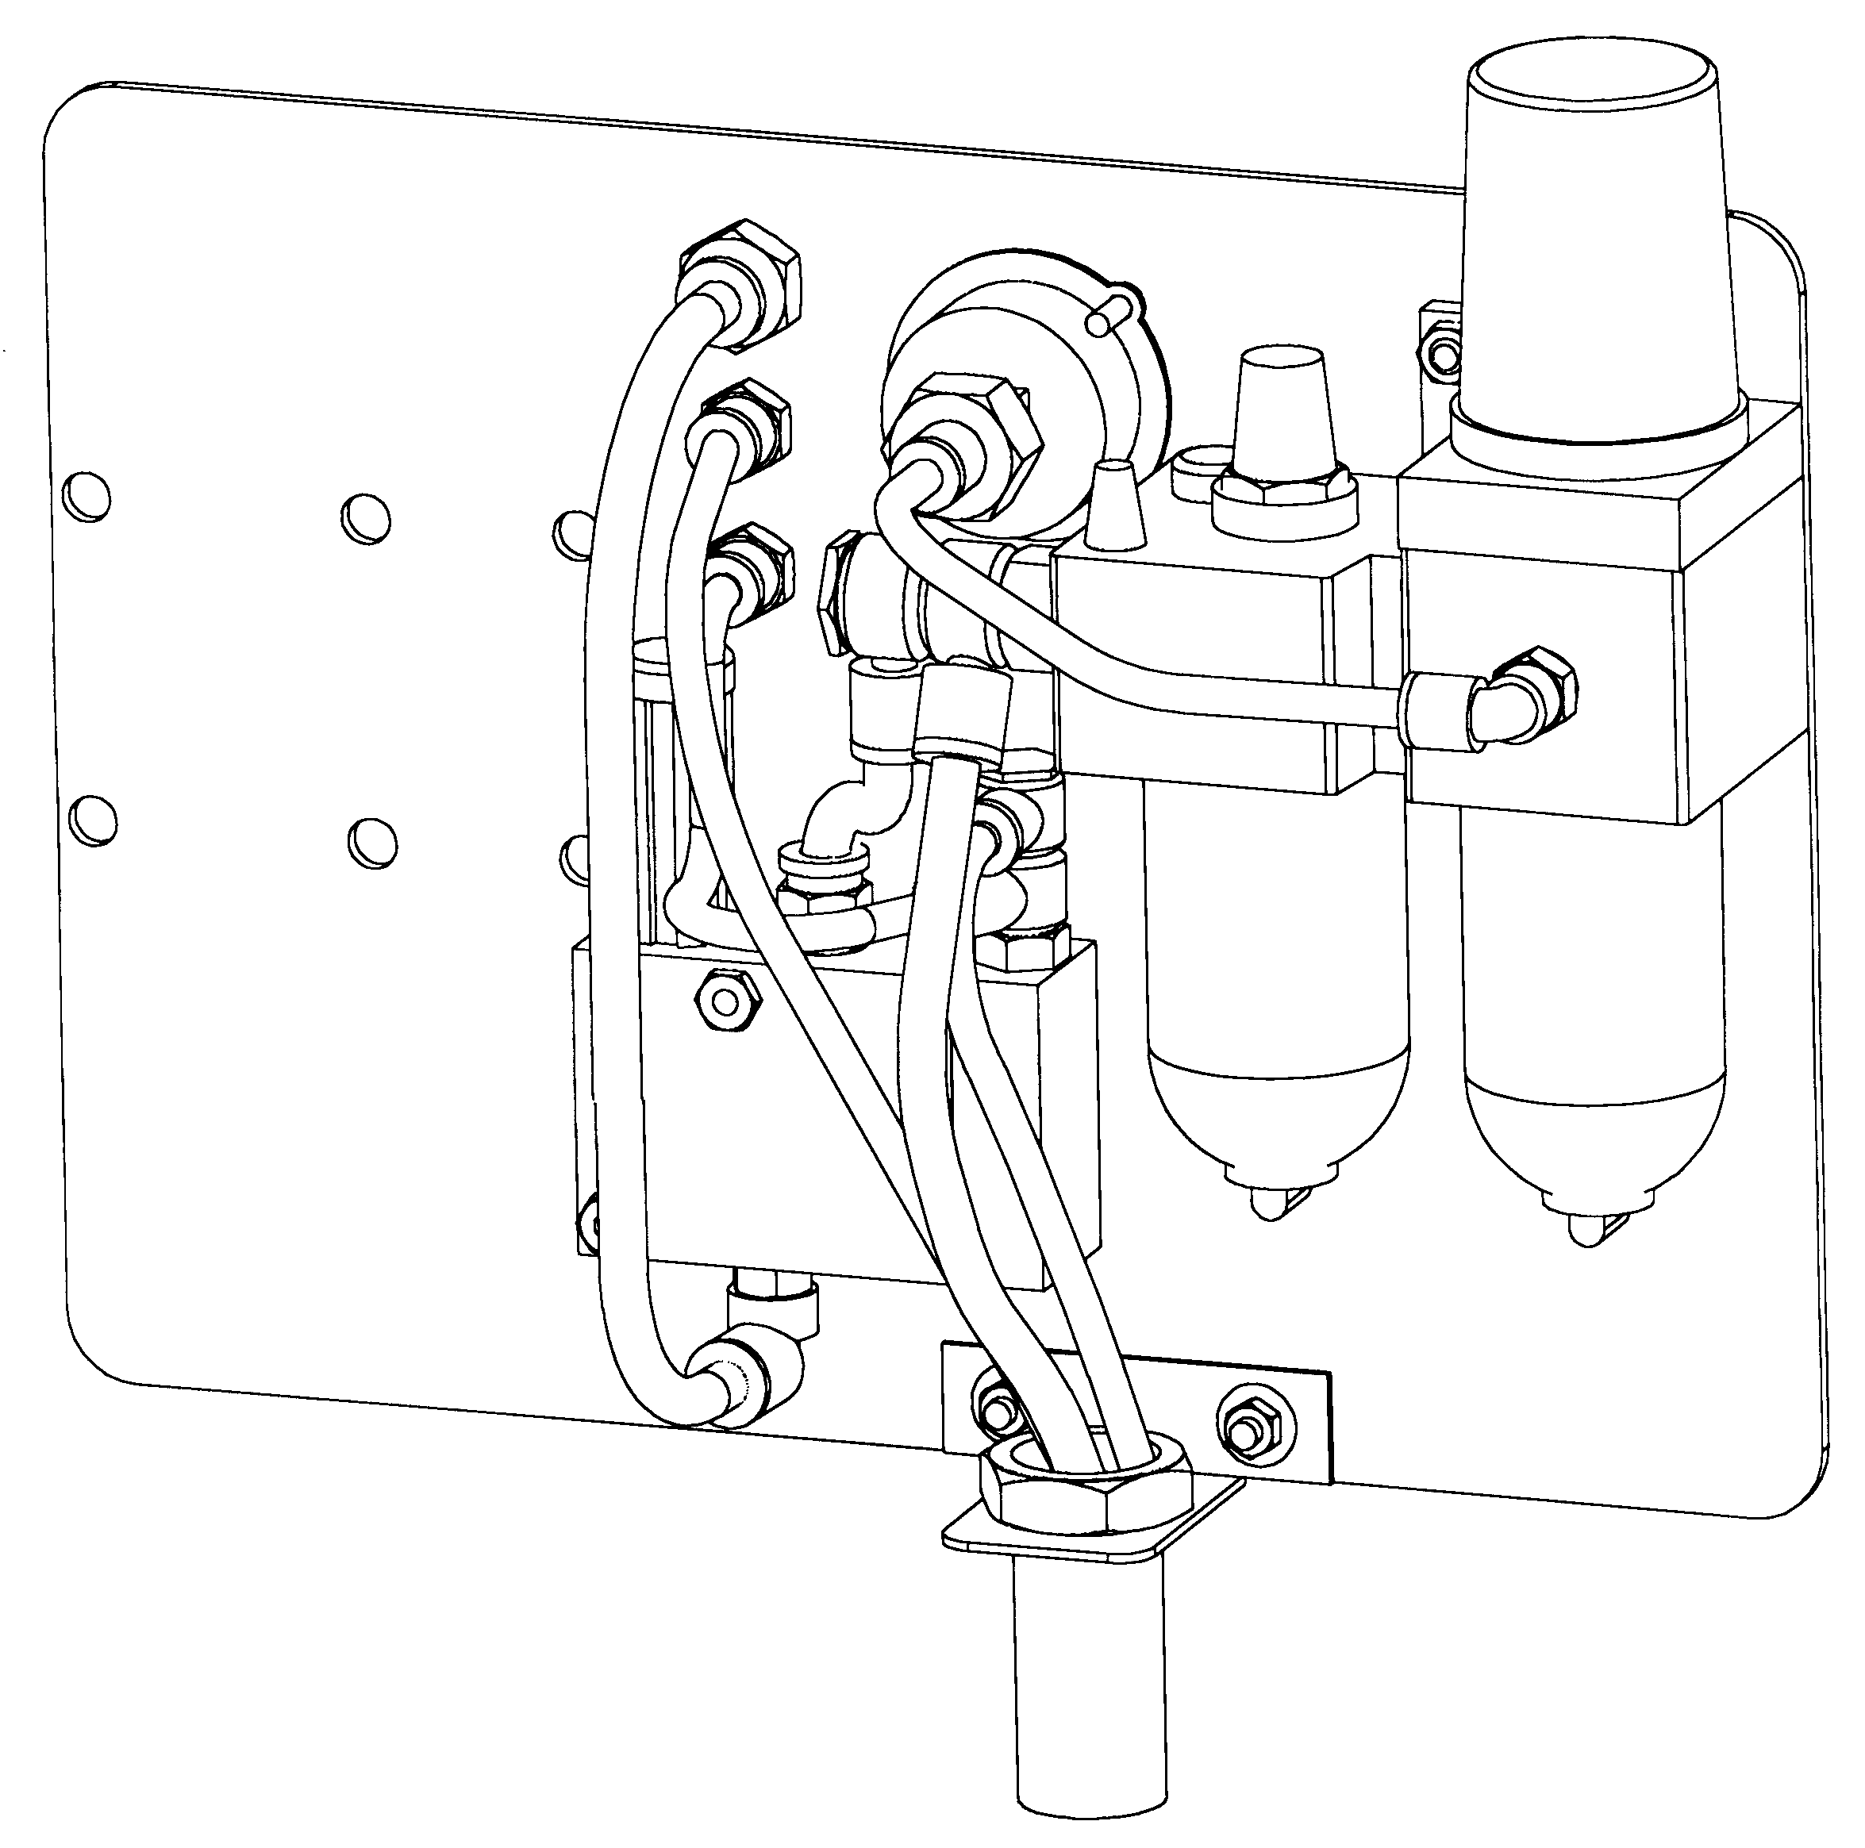
1
2
3
4
5
6
7
8
FIGURE 7

COMMERCIAL WARRANTY
This equipment is warranted by Bruno Wessel, Ltd., to the original end user, against defects in materials or workmanship, for a period of one (1) year from date of purchase (90 days for hoses, gauges and hose chucks). During the warranty period, any equipment found to be defective will be repaired or replaced (at factory's option) without charge.
To request warranty service, you must contact the factory. If the equipment must be returned, then a warranty registration number (WRN) will be issued. This WRN must be shown on all shipping labels and shipping documents. The equipment must be shipped with the transportation charges fully prepaid, The equipment will be repaired or replaced and returned at factory's expense. Any equipment returned without following this procedure will be refused.

This warranty does not cover defects caused by ordinary wear and tear, abuse, misuse, overloading, accident, shipping damage, improper maintenance, alteration, use with improper fluids or fluid levels, improper or contaminated air supply, or any other cause not the result of defective materials or workmanship.
Any equipment that is repaired or replaced, within the warranty period, shall not extend the original warranty period. Any purchased service part that is defective in materials or workmanship will be repaired or replaced by the factory, if so defective within 90 days of purchase.
REPAIR OR REPLACEMENT IS THE EXCLUSIVE REMEDY FOR DEFECTIVE EQUIPMENT UNDER THIS WARRANTY. THIS WARRANTY IS EXPRESSLY IN LIEU OF ALL OTHER WARRANTIES, INCLUDING ANY IMPLIED WARRANTY OF MERCHANTABILITY OR FITNESS FOR A PARTICULAR PURPOSE.

BRUNO WESSEL

BRUNO WESSEL LTD.
IN CANADA

1-800-465-3464
Tel. (519) 452-1935
Fax (519) 452-3911

BRUNO WESSEL INC.

IN USA

1-800-869-1908
Tel. (914) 3817771
Fax (914) 381-7775

